Follow Me
Intentional Leadership
October 7, 2018

Chris Stull, Pastor
And He said to them, “Follow Me, and I will make you fishers of men.” Matthew 4:19 NASB
John 6:2-14
Intentional Leaders . . .
- Jesus
- Jesus had in what he was to do
- Jesus had a
- Jesus called out and to him
- Jesus responded to the moment
- the game
- the players
- an environment for growth
Understanding Roles:
God’s Role – He moves in the / of men
Our Role – to see where God is working & Him
Disciple’s Role – Christ, God to make, for men
Follow Me
Intentional Leadership
October 7, 2018

Chris Stull, Pastor
And He said to them, “Follow Me, and I will make you fishers of men.” Matthew 4:19 NASB
John 6:2-14
Intentional Leaders . . .
- Jesus
- Jesus had in what he was to do
- Jesus had a
- Jesus called out and to him
- Jesus responded to the moment
- the game
- the players
- an environment for growth
Understanding Roles:
God’s Role – He moves in the / of men
Our Role – to see where God is working & Him
Disciple’s Role – Christ, God to make, for men
What’s Up @ Wellspring . . .
October 10 Wellspring Women host The Pink Project - A night of service with a mission to comfort those on a cancer journey on Wednesday, October 10 from 6:30 – 8:30 pm at Palm Valley Community Center (14145 W. Palm Valley Blvd., Goodyear, AZ 85395)
October 21 Pizza with the Pastor
November 4 Baptism

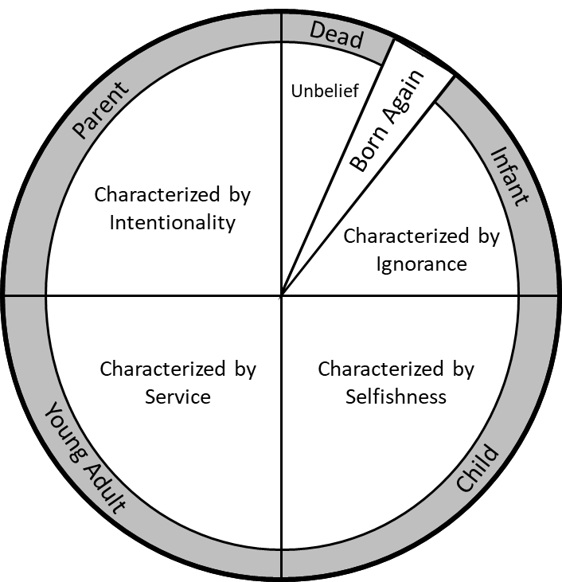

What’s Up @ Wellspring . . .
October 10 Wellspring Women host The Pink Project - A night of service with a mission to comfort those on a cancer journey on Wednesday, October 10 from 6:30 – 8:30 pm at Palm Valley Community Center (14145 W. Palm Valley Blvd., Goodyear, AZ 85395)
October 21 Pizza with the Pastor
November 4 Baptism

