Follow Me
How Disciples Grow
September 23, 2018

Chris Stull, Pastor
And He said to them, “Follow Me, and I will make you fishers of men.” Matthew 4:19 NASB
Stages of Spiritual Life & Growth:
- The Spiritually
And you were dead in your trespasses and sins, in which you formerly walked according to the course of this world,
Ephesians 2:1 NASB
- The Spiritual
. . . Just as a nursing mother cares for her children, so we cared for you. Because we loved you so much, we were delighted to share with you not only the gospel of God but our lives as well.
1 Thessalonians 2:7-8 NIV
- The Spiritual
- The Spiritual
Do nothing out of selfish ambition or vain conceit. Rather, in humility value others above yourselves, 4 not looking to your own interests but each of you to the interests of the others.
Philippians 2:3-4 NIV
- The Spiritual

Follow Me
How Disciples Grow
September 23, 2018

Chris Stull, Pastor
And He said to them, “Follow Me, and I will make you fishers of men.” Matthew 4:19 NASB
Stages of Spiritual Life & Growth:
- The Spiritually
And you were dead in your trespasses and sins, in which you formerly walked according to the course of this world,
Ephesians 2:1 NASB
- The Spiritual
. . . Just as a nursing mother cares for her children, so we cared for you. Because we loved you so much, we were delighted to share with you not only the gospel of God but our lives as well.
1 Thessalonians 2:7-8 NIV
- The Spiritual
- The Spiritual
Do nothing out of selfish ambition or vain conceit. Rather, in humility value others above yourselves, 4 not looking to your own interests but each of you to the interests of the others.
Philippians 2:3-4 NIV
- The Spiritual

What’s Up @ Wellspring . . .
September 23 Pizza with the Pastor
September 26 See You at the Pole @ Students’
Schools
September 29 Love Your Schools Day (Millennium
High School)
September 30 New Membership Class
October 10 The Pink Project (6-8PM)
Palm Valley Community Center

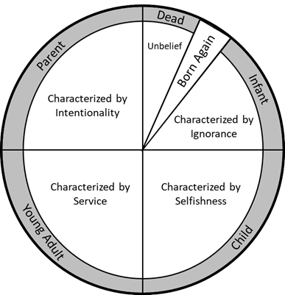

What’s Up @ Wellspring . . .
September 23 Pizza with the Pastor
September 26 See You at the Pole @ Students’
Schools
September 29 Love Your Schools Day (Millennium
High School)
September 30 New Membership Class
October 10 The Pink Project (6-8PM)
Palm Valley Community Center

